

23.01.2022 PLANT-O-METER

GTU CSE101 FALL TERM PROJECT

Contents

Problem Description 2

Needs For The Project 2

Need For Project 2

How It Operates and Description of Our Solution 2

System Block Diagram and Necessary Drawings 3

Output and Benefits of the Project 4

Inputs and Outputs 4

Results and Conclusion 4

Task Distribution 5

References 5

Problem Description

Plant-o-meter is a machine that measures the components which is essential for plant and seed growth.

Due to the economical crisis going on in Turkey, we thought it would be a great idea to support the farmer ecosystem in this circumstances since they are being affected from this crisis the most.

We decided to go on with Plant-o-Meter since its equivalents are much more expensive then how much it cost for us to do.

But the final decision came from the thought about helping the Earth to become greener again because with the help of Plant-o-meter we can see the exact amounts and with that, we can create ideal circumstances for each plant to grow.

Needs For The Project

Arduino UNO set

LM35 temperature sensor

LDR light sensor

Humidity sensor

LCD panel

10k potentiometer

220 OHM Resistor

MQ135 gas sensor

Need For Project

Our country’s agriculture potential is higher than most of the countries in the World. And our aim is adding technology to our agriculture and make things simple for our farmers.And also we need to make it cheap to make access easier. For these reason we made this Project.

How It Operates and Description of Our Solution

We set sensors for measuring conditions. LM35 temperature sensor for measuring temperature, LDR light sensor for light density, Humidity sensor for soil moisture, Gas sensor for CO2 amount in the air.

We make arduino to print the results from sensors to LCD screen whose screen brightness is adjusted by the potentiometer.

System Block Diagram and Necessary Drawings

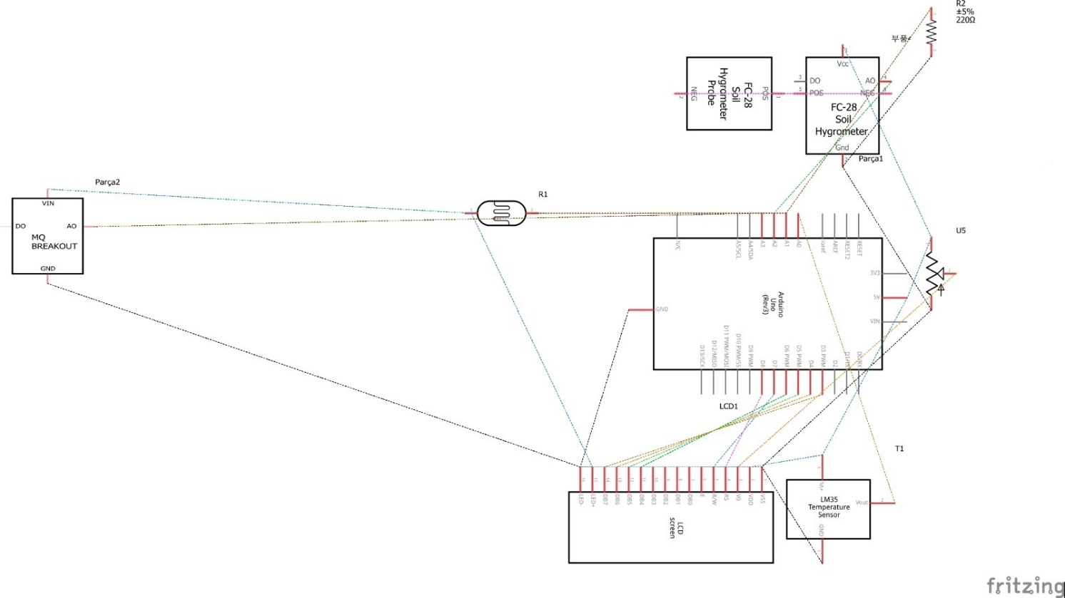

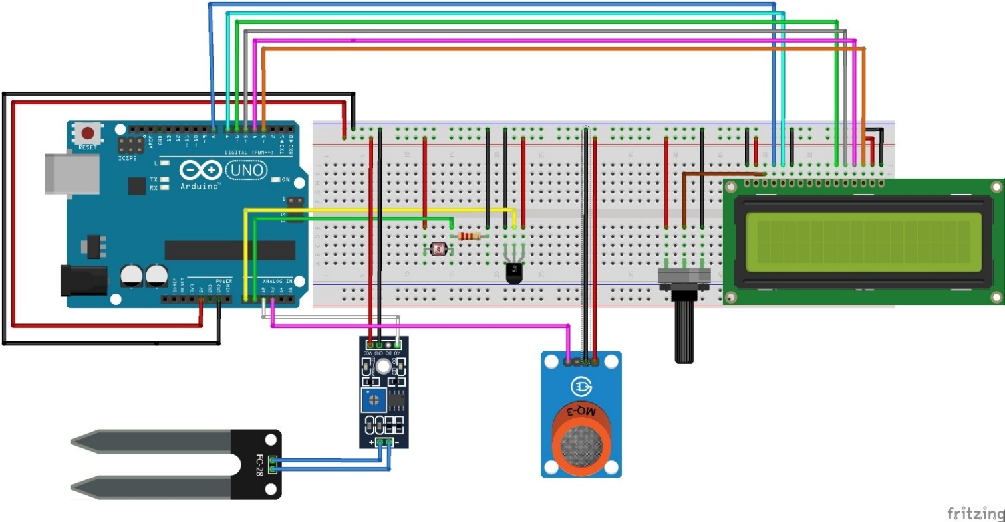

Output and Benefits of the Project

After measuring the conditions we make arduino print the results in a LCD panel. The conditions will appear in the screen with 3 seconds delay between each result. So the user can see if the values are optimum or not and modify the conditions to the optimum values. That will make the plant grow.

Inputs and Outputs

From sensors we get inputs which are temperature, light density, soil moisture, CO2 amount in the air. And we convert the input values and print them on the LCD screen.

Results and Conclusion

We succesfully measure the conditions of an enviroment with a cheaper price. Our project costs 191 Turkish Liras when devices for each condition costs about 2000 Turkish Liras online. So the farmers can provide our device and we can make earth more greener. Our Project can be improved by adding a measuring minerals in the soil function we fail to construct because of lack of experience and knowladge. It can also be customized. We can put the optimum conditions for only one type of plant. For example coton. By doing this we can make the arduino decide if the conditions are suitable for coton or not. There are few things we struggle with. Calibrating the light sensor was one of them. We also had difficulties while deciding the project. Our main goal was to help farmer ecosystem and there were many options. It was hard to choose.

Task Distribution

Temperature: Recep Furkan Akın

Light: Barış Batuhan Bolat & Yiğit Karaduman

Humidity: Tuğrul Yapıcı & Melike Seyitoğlu

Air Quality: Enes Akar & Serdar Genç

LCD: Barış Batuhan Bolat

Demo: Barış Batuhan Bolat & Enes Akar

Video and Slide Representation: Yiğit Karaduman

Report:Melike Seyitoğlu & Recep Furkan Akın

References

<https://www.viparspectra.com/blogs/home-grower/5-factors-affecting-plant-growth>

<https://www.digikey.com/en/maker/projects/design-a-luxmeter-with-an-ldr-and-an-arduino/623aeee0f93e427bb57e02c4592567d1>

<https://maker.pro/arduino/projects/arduino-soil-moisture-sensor>